Design Document

Automated Store Replenishment Using Distributed Objects (AutoRep)

CS 441

Group members

Anirudh Ramnath,
Gowdhaman Sadhasivam,
Karthik Hariharan,
Venkatesan Ravichandran

University of Illinois at Chicago
Fall 2014

Table of Contents
1 Introduction 3
2 Business Objects 3
2.1 Dashboard Object 3
2.2 Authentication Object 3
2.3 Load Balancer Object 4
2.4 Logistics Manager Object 4
2.5 Replenishment Analyzer Object 4
2.6 Database Object 4
3 Design Diagrams 5
3.1 Database Design Diagram 5
3.2 System Architecture 6
3.3 Use Case Diagram 7
3.4 Class Diagram 8
3.5 Sequence Diagram 9
3.6 State Diagram 10
3.7 Component Diagram 11
3.8 Package Diagram 12

Introduction

The AutoRep application is broken down into 10 objects namely, Dashboard Object, Authentication Object, Load Balancer, Logistics Manager, Replenishment Analyzer Object, Data Retrieval Agent, Store Object, Warehouse Object, Product Object and Database Object. The description for each of the classes is given in the following sections.

Business Objects

Dashboard Object

The Dashboard Object is the main point of access to the distributed application and is the only part of the system that the user interacts with. Typically, there are multiple instances of the Dashboard Object at a time to represent each of the different users that are using the system at a time. This object lets the user interact with the system and view details about the inventory status and accept replenishment requests. When the user logs in, the Dashboard Object lists inventory details of his/her corresponding store. This is done when a client sends a request to the Load Balancer after successful authentication. The Load Balancer delegates the processing of this user’s request to a particular Logistics Manager and sends the response back to the Dashboard Object. Alternatively, if the user needs to be alerted about a replenishment request that the user must accept/reject, the Replenishment Analyzer will go through the database and alert the corresponding Store Manager through their corresponding Dashboard Object. The corresponding store manager must then later decide if they want to accept or reject the replenishment request and his/her decision will again be sent using the Dashboard Object to the Load Balancer.

Authentication Object

The Authentication Object is used to perform authentication of the Store Managers users in the system. The user enters his/her username and password and this object is responsible for ensuring that the username and password matches the corresponding records that are present in the NoSQL database. If the authentication details are valid, then the Store Manager is given access to the system, otherwise the corresponding user is prevented access into the system.

Load Balancer Object

To improve the scalability of our distributed application and distribute traffic among web servers, we use Load balancers. When more users logs-into the system to manage the auto-generated Replenishment requests, the Load balancer object gets the user selected replenishment requests from the replenishment analyzer which are generated automatically using Batch process and forwards these requests to one of the web-servers which has the least load on it. Hence Load balancer helps to avoid the “Single point failure” and higher fault tolerance in our application.

Logistics Manager Object

A Logistics Manager Object communicates with the Load Balancer to process data to achieve a certain task that is delegated to it by the Load Balancer. The Logistics Manager only performs the tasks that are delegated to it and has no knowledge about which user requires the output of its data. Logistics Managers are typically used to parallelize computations on the database in order to prevent a bottleneck during DB accesses. Logistics Managers talk to both the Load Balancer as well as the Data Retrieval Agent. The Load Balancer gives the Logistics Manager instructions on what function to perform and the Data Retrieval Agent in order to retrieve data from the database in order to perform the functions it is delegated.

Replenishment Analyzer Object

The Replenishment Analyzer Object is the object that performs checks on the database to look into the Store Keeping Unit (SKU) of various stores to keep checks on the inventories of various stores. This object is used to alert Store Managers in case of a lack of inventory in their corresponding store. This object periodically scans the database for products that are less in quantity in specific stores and then raises flags for the products that need to be replenished.

Database Object

The database object retrieves and stores data into the database. It communicates with the replenishment analyzer and the logistics manager and facilitates data exchange between them and the database.

Design Diagrams

Database Design Diagram

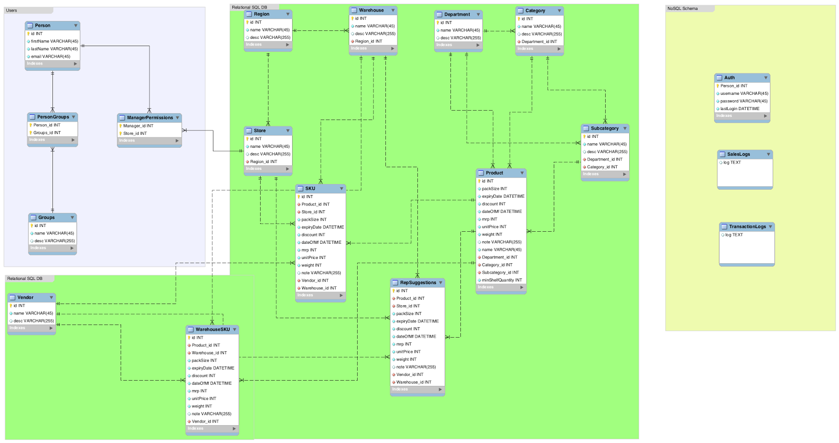

System Architecture

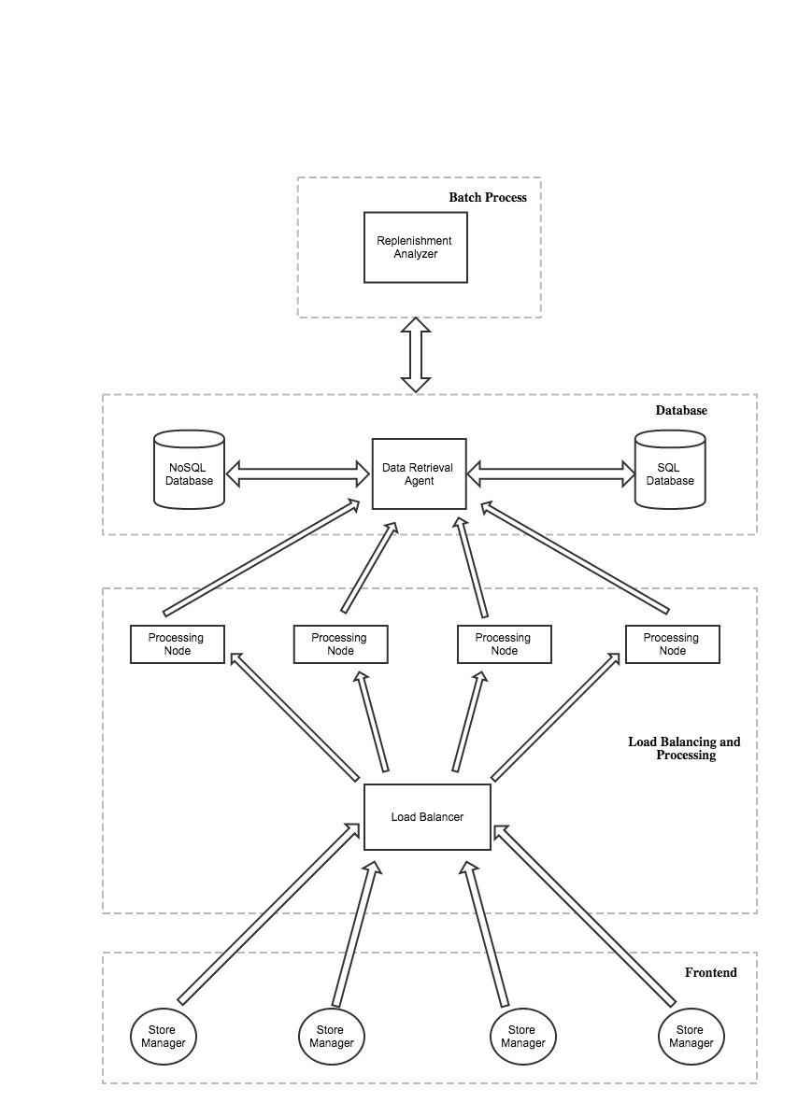

Use Case Diagram

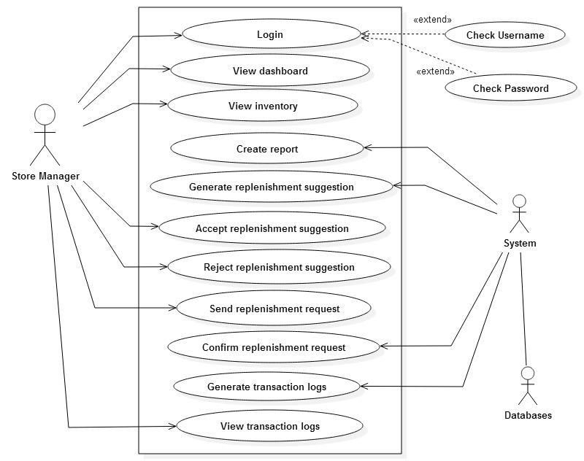

Class Diagram

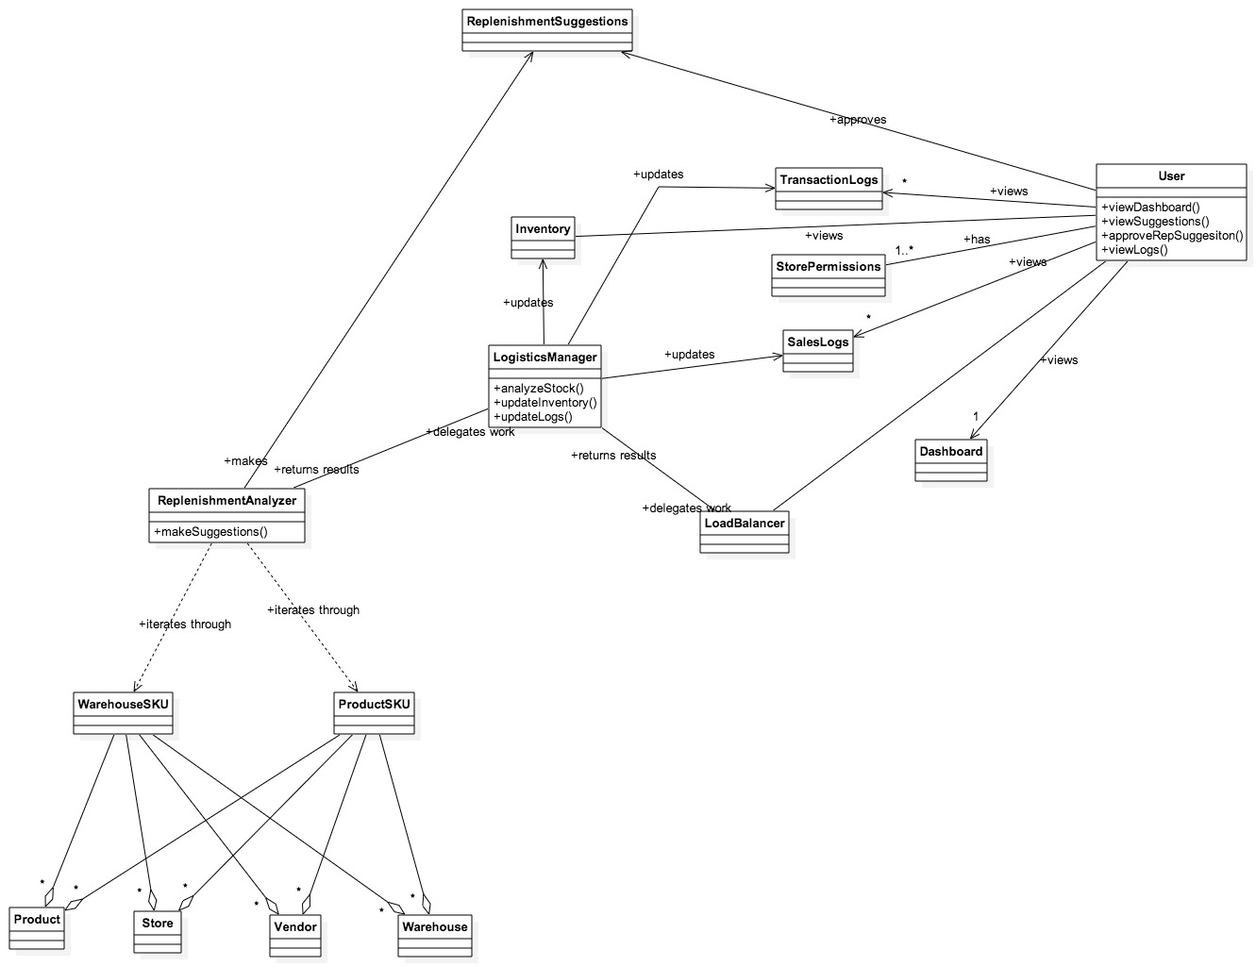

Sequence Diagram

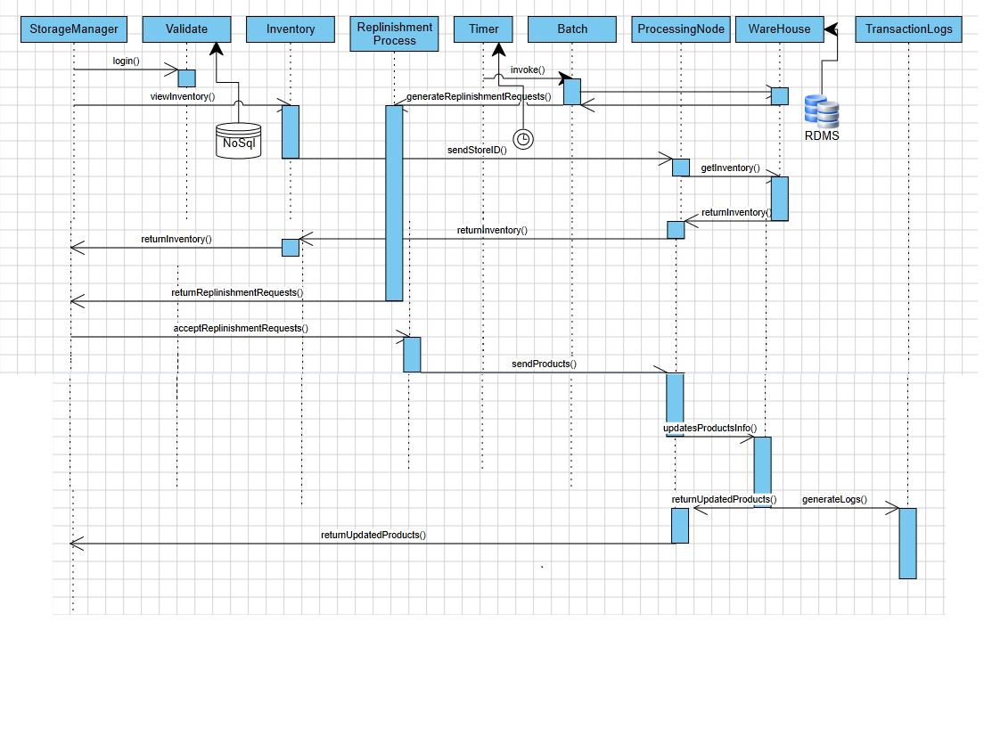

State Diagram

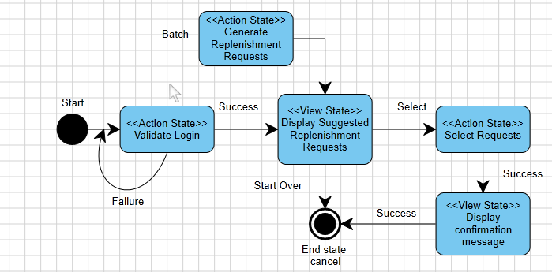

Component Diagram

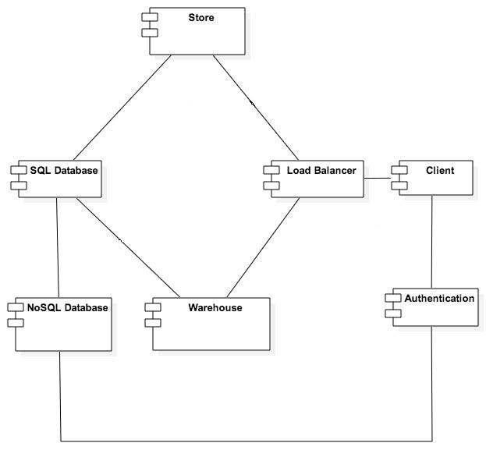

Package Diagram

